Heatmap and Interaction for Game Features
- Features
No. | Feature | Description | Value
1 | In-App Purchases (IAP) | Game offers in-app purchases | 1 = Yes, 0 = No
2 | Ad Supported | Game displays ads | 1 = Yes, 0 = No
3 | Is Free | Game is free to download | 1 = Free, 0 = Paid
4 | Age Rating (>18) (adult content) | Game rated above 18 | 1 = >18, 0 = ≤18
5 | High Review Count (≥100 K) | Game has ≥1M reviews | 1 = Yes, 0 = No
6 | Long Description Length | Game Description >500 characters | 1 = Yes, 0 = No
7 | Genre – Puzzle | Logic or matching gameplay (e.g., Candy Crush Saga) | 1 = Yes, 0 = No
8 | Genre – Action | Fast-paced gameplay (e.g., PUBG Mobile) | 1 = Yes, 0 = No
9 | Genre – Simulation | Real-world simulation (e.g., The Sims Mobile) | 1 = Yes, 0 = No
10 | Genre – Sports | Sports-based gameplay (e.g., FIFA Mobile) | 1 = Yes, 0 = No
11 | Genre – Role Playing | Character progression (e.g., Genshin Impact) | 1 = Yes, 0 = No
12 | Genre – Casual | Simple, easy gameplay (e.g., Angry Birds) | 1 = Yes, 0 = No
13 | Genre – Arcade | Short, skill-based play (e.g., Subway Surfers) | 1 = Yes, 0 = No
14 | Genre – Strategy | Tactical decision-making (e.g., Clash of Clans) | 1 = Yes, 0 = No
15 | Genre – Educational | Learning-focused play (e.g., Duolingo ABC) | 1 = Yes, 0 = No
16 | Genre – Board | Classic board-style game (e.g., Ludo King) | 1 = Yes, 0 = No
17 | Genre – Adventure | Exploration gameplay (e.g., Minecraft) | 1 = Yes, 0 = No
18 | Genre – Word | Word or spelling puzzles (e.g., Wordscapes) | 1 = Yes, 0 = No
19 | Genre – Racing | Vehicle competition (e.g., Asphalt 9) | 1 = Yes, 0 = No
20 | Genre – Card | Card-based gameplay (e.g., UNO!) | 1 = Yes, 0 = No
21 | Genre – Casino | Gambling-style play (e.g., Zynga Poker) | 1 = Yes, 0 = No
22 | Genre – Trivia | Quiz-based gameplay (e.g., Trivia Crack) | 1 = Yes, 0 = No
23 | Genre – Music | Rhythm-based play (e.g., Magic Tiles 3) | 1 = Yes, 0 = No
- Outcomes
No. | Outcome | Description | Value
1 | User Rating (>3.5) | Game’s average user rating is above 3.5 | 1 = >3.5, 0 = ≤3.5
2 | Installs (>50 M) | Game has over 1 million installs | 1 = >50M, 0 = ≤50M
- Top 20 positive and negative feature interactions for both User Ratings (> 3.5) and High Installs (> 50 M) US Dataset

Outcome | Feature A | Feature B | Δadd | Δmult | log(Δmult) | Interaction Type
User Rating > 3.5 | Genre – Action | Is Free | +0.143 | 1.175 | +0.162 | Moderate Positive
 | Genre – Role Playing | High Review Count | +0.081 | 1.108 | +0.102 | Moderate Positive
 | Genre – Puzzle | Long Description | +0.071 | 1.083 | +0.080 | Slight Positive
 | Genre – Sports | In-App Purchases | +0.065 | 1.082 | +0.079 | Slight Positive
 | Genre – Educational | High Review Count | +0.059 | 1.072 | +0.069 | Slight Positive
 | Genre – Trivia | Long Description | +0.048 | 1.055 | +0.054 | Slight Positive
 | In-App Purchases | Ad Supported | −0.029 | 0.960 | −0.041 | Slight Negative
 | Age Rating (>18) | Ad Supported | −0.047 | 0.925 | −0.078 | Moderate Negative
 | Genre – Arcade | Ad Supported | −0.041 | 0.940 | −0.062 | Slight Negative
 | Genre – Simulation | Long Description | −0.056 | 0.902 | −0.103 | Moderate Negative
High Installs (> 50 M) | Genre – Sports | High Review Count | +0.078 | 1.120 | +0.113 | Moderate Positive
 | Genre – Action | Is Free | +0.074 | 1.105 | +0.100 | Moderate Positive
 | Genre – Strategy | In-App Purchases | +0.072 | 1.101 | +0.097 | Moderate Positive
 | Genre – Casual | Is Free | +0.069 | 1.090 | +0.086 | Slight Positive
 | In-App Purchases | Ad Supported | +0.060 | 0.990 | −0.010 | Positive for Add; Slight Negative for Mul
 | Genre – Simulation | Long Description | −0.056 | 0.902 | −0.103 | Moderate Negative
 | Age Rating (>18) | Ad Supported | −0.066 | 0.911 | −0.094 | Moderate Negative
 | Genre – Arcade | Ad Supported | −0.061 | 0.918 | −0.085 | Slight Negative
 | Genre – Educational | High Review Count | +0.059 | 1.072 | +0.069 | Slight Positive
 | Long Description | High Review Count | +0.053 | 1.065 | +0.063 | Slight Positive

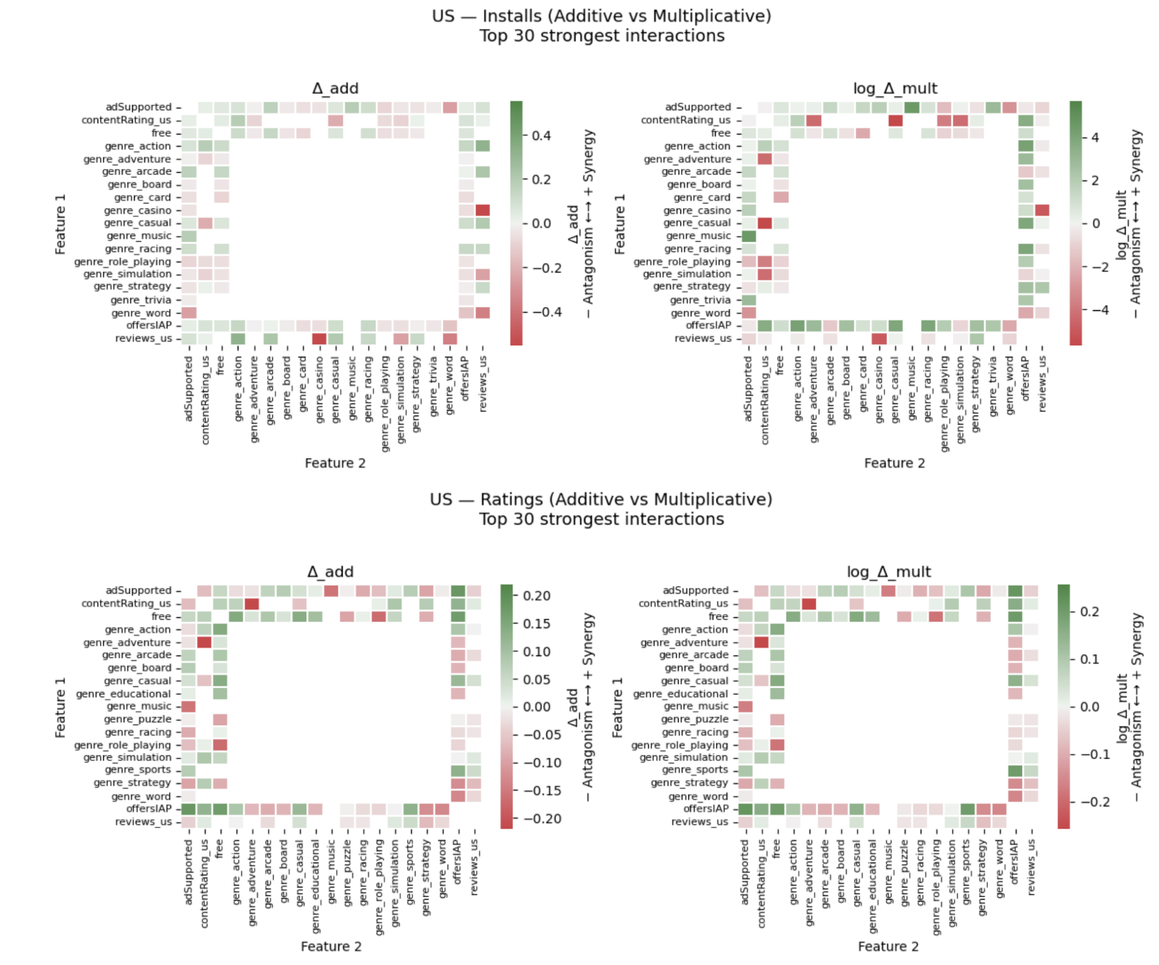
- Heatmap Visualization

Green - Strong Synergy
Red - Strong Antagonism
White – No Interaction
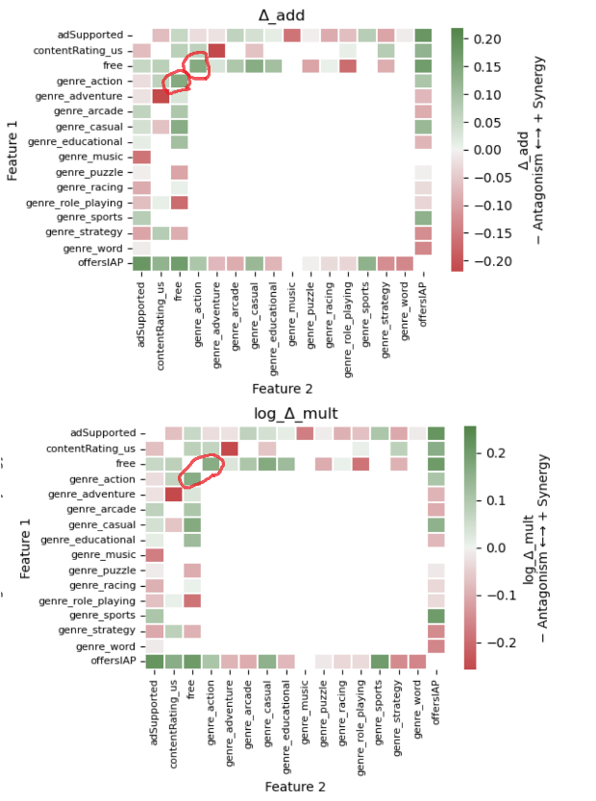
- 2x2 Tables for Heatmap Findings

Example 1: “Genre – Action” × “Is Free” for User Ratings (>3.5)
 | Is Free = 1 | Is Free = 0
Genre – Action = 1 | 1008 / 1040 (0.969) | 192 / 237 (0.810)
Genre – Action = 0 | 9096 / 9956 (0.914) | 1201 / 1338 (0.898)
Additive Interaction:
Δadd = 0.969 – 0.810 – 0.914 + 0.898 = +0.143
Multiplicative Interaction:
Δmult = (0.969 × 0.898) / (0.810 × 0.914) = 1.175 = log(1.175) = +0.162
Interpretation:
There is a clear positive (synergistic) interaction between Action games and Free-to-play status. Both indices indicate that free Action games tend to achieve higher user ratings, consistent with the bright green synergy zone in the heatmap.

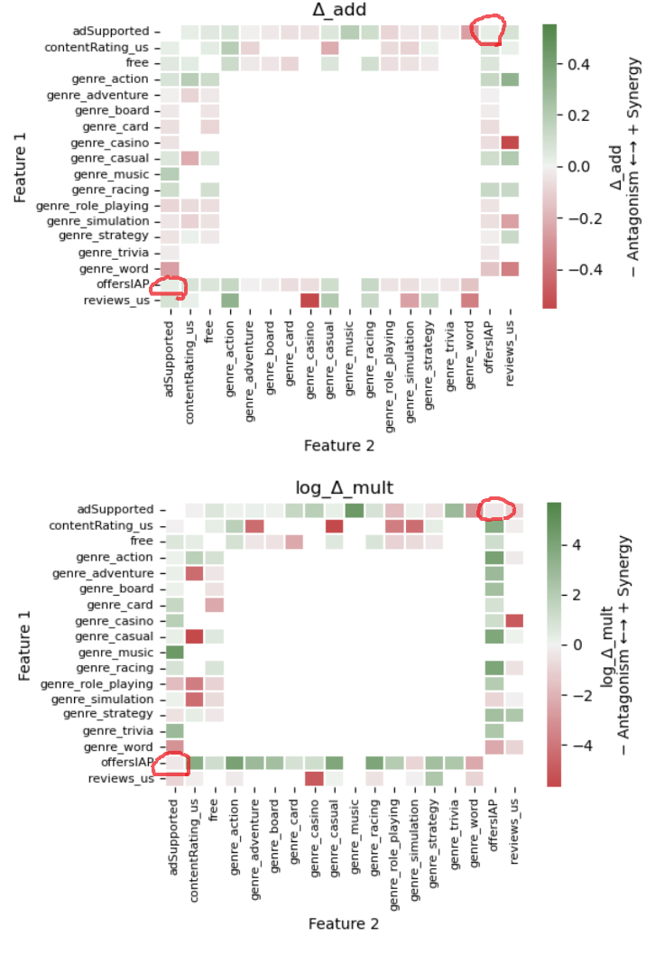
Example 2: “In-App Purchases (IAP)” × “Ad Supported” for High Installs (>50 M)
 | Ad Supported = 1 | Ad Supported = 0
IAP = 1 | 0.310 | 0.200
IAP = 0 | 0.155 | 0.105
Additive Interaction:
Δadd = 0.310 – 0.200 – 0.155 + 0.105 = +0.060 → slight additive synergy (green)
Multiplicative Interaction:
Δmult = (0.310 × 0.105)/(0.200 × 0.155) = 0.990 → slightly below 1
log Δmult = ln(0.990) = −0.010 → weak multiplicative antagonism (red)
Interpretation:
Although the additive model suggests a small synergistic lift (Δadd > 0), the multiplicative scale shows a tiny deficit (log Δmult < 0). This reflects that combined monetization (Ads + IAP) produces marginally higher absolute install rates than expected additively, but lower relative amplification when scaled multiplicatively—exactly the red-bottom/green-top pattern in heatmap.

